# DDIC Tables

Data Dictionary tables is central repository where we can create a metadata like data base table, view and domain, etc. To accessing Tables we use SE11 T-code.

Following are the components in Data Dictionary:

* Database Tables
* View
* Data Type
* Type group
* Domain
* Search Help
* Lock Objects

## Steps to create transparent table:

1. Open T-code: SE11
   1. Click on Database table and give any table name.
   2. Click create button to get it create and add the Package name.
2. Provide the short description (with spaces applicable)
3. On Delivery and Maintenance Tab, Delivery Class and Data Browser/Table view is there.
   1. Put Delivery Class as A (Application Table)
   2. Put X Display/Maintenance Allowed in Data Browser/Table view field.
4. Field Tab, we can add our Fieldname (w/o spaces)
5. Add the Data Element either custom or standard data element both are preferable.

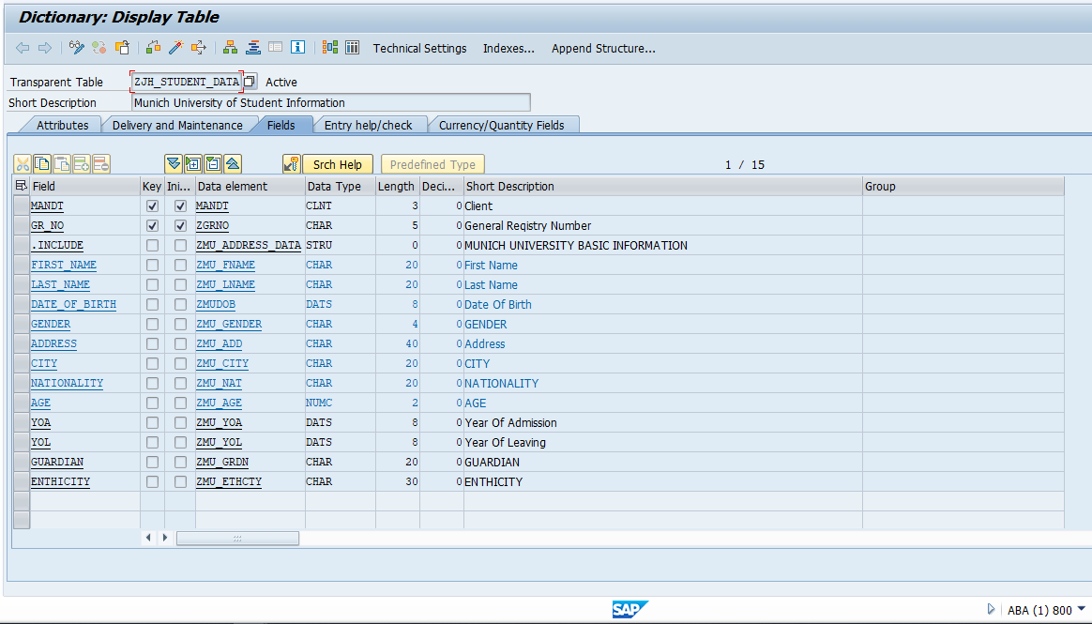

*Note: MANDT field is mandatory it is define whether the table is client-dependent or independent.*

* 1. For custom Data Element, write the Data Element name and double-click on it.
  2. In new window, Create Domain for the Data type of the Data Element.
  3. SAVE -> CHECK -> ACTIVATE.

1. Entry help/check Tab is optional, until and unless using any Foreign key mapping.
2. Currency/Quantity Fields Tab is optional too, if using any Currency Data element or Unit data element then we have to add the reference field name there. Prefer tables are TCURC for Currency and T006 for Unit both are standard tables.

TABLE FIELD

TCURC WAERS

T006 MSEHI

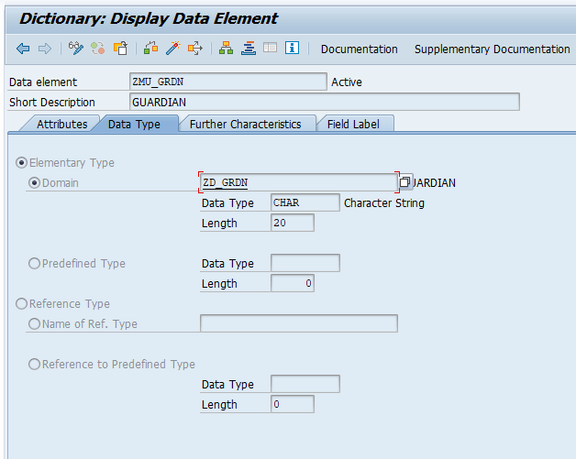

Data Element: ZMU_GRDN

Short Description: GUARDIAN

Field Label: Add the text on all 4 fields.

Create Domain in Data Type tab.

Domain: ZD_GRDN

*\*After creation of Domain then only Data type and Length will display in Data Element.*

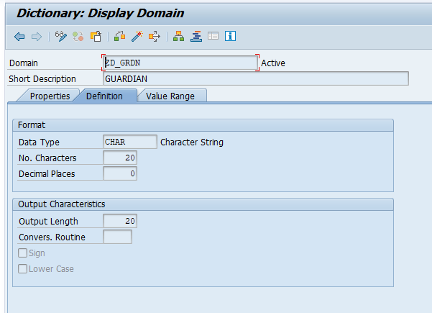

Domain: ZD_GRDN

Short Description: GUARDIAN

Data Type: CHAR

No. Characters: 20

Output Length: 20

1. Click on Technical Settings tab in Main page for adding the Data class and size category.

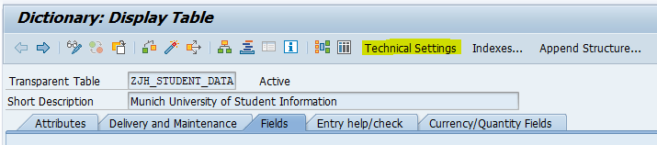

1. On General Properties Tab.
   1. Data Class: APPL0 {APPL0, APPL1, APPL2}
   2. Size Category: 8 {size category = n, 0 <= 9 }
   3. Buffering Not Allowed
   4. Click on Revised <-> Active and save.
2. SAVE -> CHECK -> ACTIVATE

*Note: Table Maintenance Generator is optional if business requires we can create TMG for tables.*

*On Menu Bar, Utilities > Table Maintenance Generator.*

*Authorization Group: &NC& FUNCTION GROUP: Table_name*

*Maintenance type: one step Overview screen: 1*

In DDIC Table we have two components which are INCLUDE & APPEND.

**INCLUDE:**

Include is a structure based that we can add only in custom table. We can call this structure to multiple tables too. Writing Field and Data element same to every different DDIC table is too complicate therefore, we can make one structure and we can call the structure in Custom table by using .include parameter.

**APPEND:**

Append is also the same as INCLUDE. However, append has two features i.e. we can call APPEND structure to Custom table as well as Standard table too. In fact, to call APPEND structure we need to click an APPEND STRUCTURE button on Application bar.

# Steps to create Structure:

1. On SE11 T-code, Click on Data type and select Structure.
2. Give the components name
3. Typing Method, add 1 Types.
4. Component Type is same as Data Element.

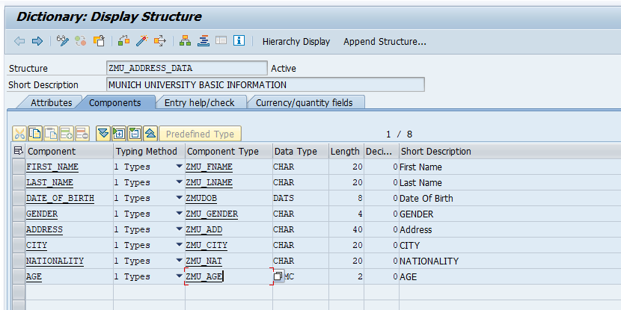

1. SAVE -> CHECK -> ACTIVATE.

Now the structure name will act as Data Element. We can add this structure in our custom table by using a Field as .INCLUDE

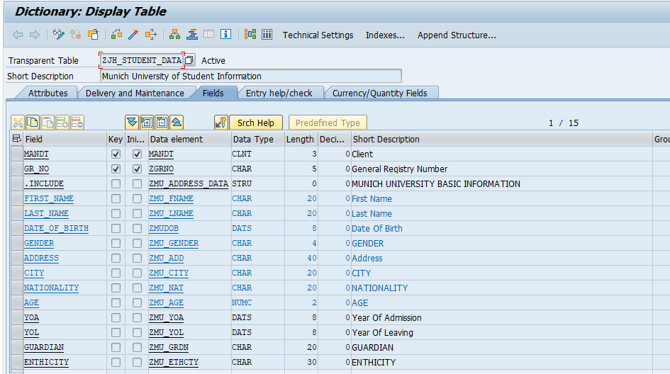

# Steps to create Search Help:

It is very good practice for custom table value-request on any fields. We can use this on Classical Reports/Interactive reports and ALV reports.

1. Open SE11 T-code and click on Search help.
2. Provide search help name and create it. e.g. ZJAYESH_ELEM
3. Choose Elementary Search Help.
4. Give the short description:
5. On Definition tab, provide the Table name on Selection method.

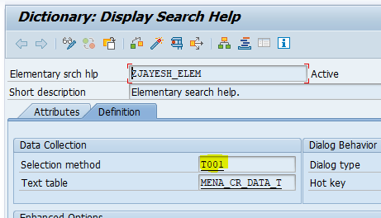

1. Add the parameters in Parameter Tab.

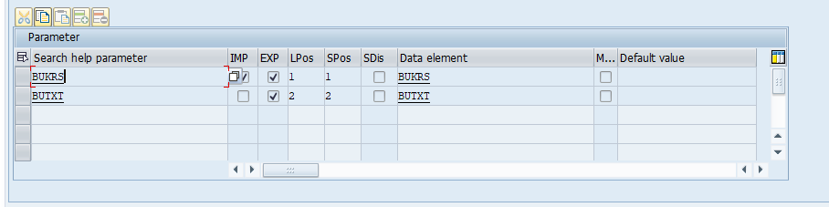

1. SAVE -> CHECK -> ACTIVATE.